Demo the Use of Docker Compose Support in Spring Boot

1. Create new Spring Boot project/module (elibrarywebapi2) and add the following dependencies:

* Spring Web
* Spring Data JDBC
* Docker Compose Support
* Postgresql Driver
* GraalVM Native Support (simply for compiling to native executables)

1. Open the ‘compose.yml’ file and edit the port setting to expose 5432 in the container to 5432 on the host machine.

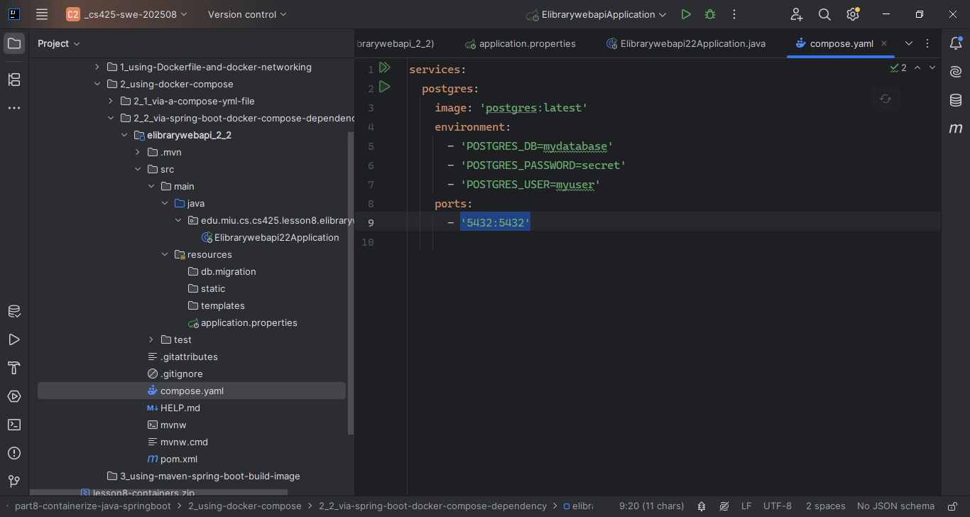

1. Open the terminal and cd to the module/project root directory and execute the command: > docker compose up

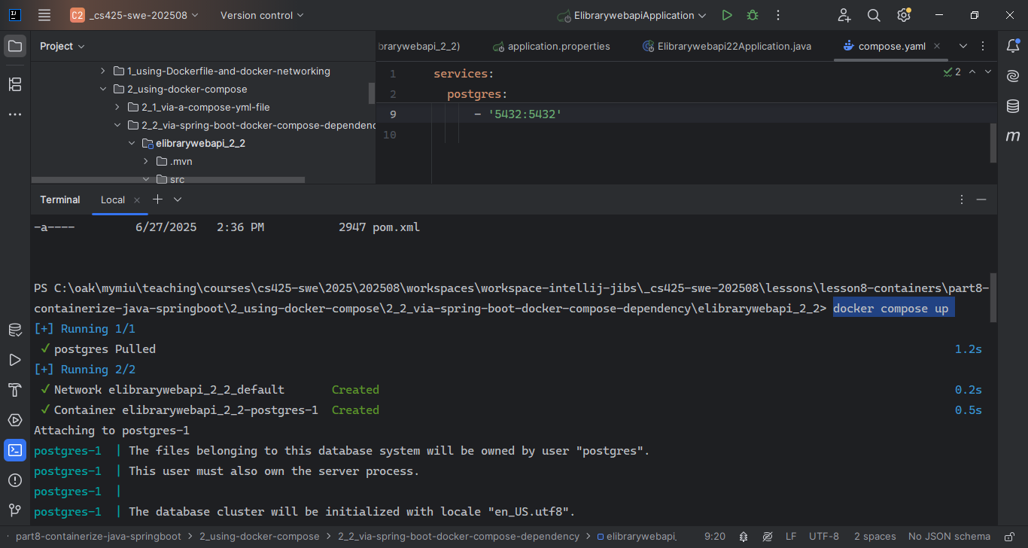

That will start the services defined in the compose.yml file

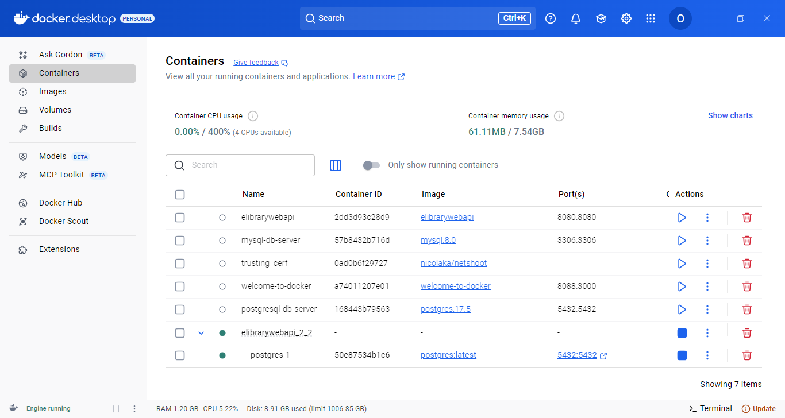

1. ...
2. ...